TOEIC LISTENING TRANSCRIPT
Practice Test 2 — Full Audio Script (Part 1, Part 2 & Part 3)

PART 1: PHOTOGRAPHS (Questions 1 – 6)
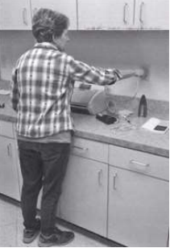
Number 1
(A) She’s inserting a cord into an outlet.
(B) She’s pressing a button on a machine.
(C) She’s gripping the handle of a drawer.
(D) She’s tacking a notice onto the wall.
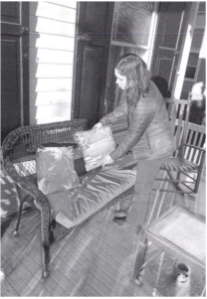
Number 2
(A) Some window shutters are being replaced.
(B) A pillow is being arranged on a seat.
(C) An outdoor table is being cleared off.
(D) Some wooden boards are being painted.
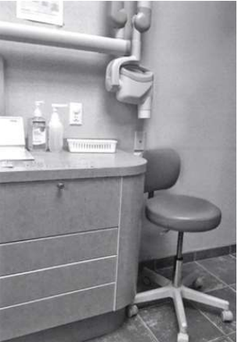
Number 3
(A) Some utensils have been discarded in a bin.
(B) Some bottles are being emptied into a sink.
(C) A rolling chair has been placed next to a counter.
(D) Some drawers have been left open.
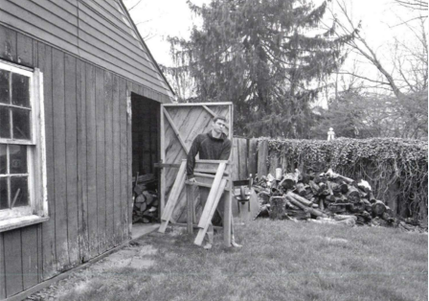
Number 4
(A) A man is chopping some wood into pieces.
(B) Leaves are scattered across the grass.
(C) A man is closing a window.
(D) Wood is piled near a fence.
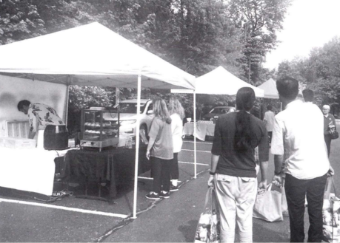
Number 5
(A) People are standing in line in a lobby.
(B) Items are being loaded into shopping bags.
(C) Tents have been set up in a parking area.
(D) A worker is putting up a canopy.
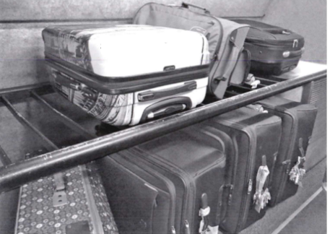
Number 6
(A) Some luggage is stacked next to an escalator.
(B) A suitcase is being lifted onto a shuttle bus.
(C) Some suitcases are displayed in a shop window.
(D) A luggage rack has two levels.

PART 2: QUESTION-RESPONSE (Questions 7 – 31)
Number 7: Have the machines on the factory floor been cleaned?
(A) No, not yet.
(B) It’s in the shipping container.
(C) I just put it in the trash bin.
Number 8: How much will the budget increase next year?
(A) About 10%.
(B) 3 hours, I think.
(C) At the bank’s main branch.
Number 9: You’re going to water the plants before you leave, aren’t you?
(A) I walked the whole way.
(B) Yes, right after lunch.
(C) In the break room.
Number 10: Aren’t you going to schedule an eye doctor appointment?
(A) Those glasses look nice on you.
(B) I already scheduled one.
(C) The seminar is three days long.
Number 11: I’m going to try to fix this printer.
(A) You’re right, it doesn’t fit.
(B) Double-sided copies.
(C) Are you sure it can be repaired?
Number 12: What should we do with these brochures?
(A) A trip to the seashore.
(B) Yes, I found it already.
(C) I’ll leave them at the front desk.
Number 13: Has the policy meeting been rescheduled?
(A) We have lots of desk calendar designs.
(B) Yes, it’s happening tomorrow instead.
(C) This soup I ordered is delicious.
Number 14: Why don’t we stop by the office cafeteria on our way to the workshop?
(A) Sure, we have time for that.
(B) A full-service buffet.
(C) The topic is professional networking.
Number 15: Have you tried our famous pasta dish?
(A) We need a table for five.
(B) Yes, it was delicious.
(C) I’ll try to make it on time.
Number 16: Who’s the opening act at tonight’s concert?
(A) Could you turn up the volume?
(B) A jazz singer from France.
(C) The position has been filled.
Number 17: When do the product demonstrations start?
(A) The schedule was emailed last Friday.
(B) Some innovative features.
(C) In room 202, I think.
Number 18: I tried updating the website, but it didn’t work.
(A) That date works for me.
(B) Usually our online reviews.
(C) Just send me the changes you want.
Number 19: Did you hire a new welding specialist?
(A) The part's back-ordered.
(B) Yes, he starts tomorrow.
(C) No, it should be higher.
Number 20: How was the color palette for the lobby chosen?
(A) Blue and orange.
(B) It was fine, thanks.
(C) I wasn’t involved.
Number 21: When are we ordering more supplies for the office?
(A) In the storage closet.
(B) Next week on Monday.
(C) The new desk looks great.
Number 22: The battery for the water pump is going to be solar powered, right?
(A) We’re still in the planning stages.
(B) $140 per year.
(C) Yes, I’d love a glass of water.
Number 23: Where can I buy a charger for this laptop?
(A) Around 3 o’clock.
(B) I can order one for you.
(C) A limited return policy.
Number 24: Do I need to reserve a meeting room?
(A) Yes, let me show you how.
(B) The service is good.
(C) My slide presentation.
Number 25: When’s the new department director supposed to start?
(A) It’s an hour long.
(B) Ms. Pavlova isn’t retiring for several weeks.
(C) No, that department’s upstairs.
Number 26: Should I deliver these pizzas, or will you?
(A) No thanks, I’m not hungry.
(B) $10 for two.
(C) They’re being picked up.
Number 27: This month’s shipment schedule has been revised.
(A) I couldn’t find them either.
(B) Which dates have been changed?
(C) $2 per pound.
Number 28: How much will the repairs cost?
(A) The work is covered under the warranty plan.
(B) Yes, it’s also available in red.
(C) In about two weeks.
Number 29: Why don’t we provide more samples of the wallpaper patterns?
(A) The newspaper is delivered daily.
(B) An interior design course.
(C) There are plenty in the binders.
Number 30: Can you give me a tour of the property this afternoon?
(A) Sorry, I won’t have time until tomorrow.
(B) It has a very modern design.
(C) A house on Maple Street.
Number 31: Who’s scheduled to test the product today?
(A) We’re waiting for confirmation.
(B) It’s a great album, right?
(C) About 6 weeks ago.

PART 3: SHORT CONVERSATIONS (Questions 32 – 70)
Questions 32–34
Man: Good morning, Captain. We’ll be docking at the port in Kolkata this evening, right?
Woman: Actually, we had to change course overnight to avoid a storm, so we’re running behind schedule. But we should arrive early tomorrow.
Man: Well, that’s not too bad.
Woman: Oh, Hector has the day off today, so I’ll need you to do the morning rounds, starting with checking the machinery in the engine room.
Man: Of course, I’ll head there now.
Question 32: Where does the conversation most likely take place?
(A) On a train (B) On a boat (C) At a factory (D) At an airport
Question 33: What caused a delay?
(A) An electrical failure occurred. (B) A worker was unavailable. (C) Some information was incorrect. (D) The weather was bad.
Question 34: What will the man do next?
A) Confirm a schedule (B) Speak to a coworker (C) Check some machinery (D) Clean a storage room
Questions 35–37
Man: Hi, I’m here to schedule some personal training sessions.
Woman: Okay, what are your fitness goals?
Man: I’d like to lift weights and build strength.
Woman: I can work with you on that. Are you currently a member here?
Man: No, I’ll also need to sign up for a membership. I saw online that you’re running a special for new members: 50% off the first month’s membership. Can I sign up for that?
Woman: Absolutely. But before I get you signed up, let me show you around our facility.
Question 35: Where does the woman most likely work?
(A) At a sports stadium (B) At a fitness center (C) At a doctor’s office (D) At a library
Question 36: What does the man ask about?
(A) A discount (B) A form (C) A business location (D) A parking policy
Question 37: What will the woman do next?
(A) Post a sign (B) Confirm an account number (C) Provide a tour (D) Look at a schedule
Questions 38–40
Woman: As you can see, this Renaissance landscape painting we acquired is in bad condition. We can’t display it yet.
Man: Hmm, yes. This painting will need significant restoration work.
Woman: I’ll begin by investigating the artist’s color palette and style to see how we should repair the damaged areas.
Man: You know, this would be a stunning piece to unveil at our anniversary dinner in June. And since it’s a big project to finish by then, we should get started right away.
Question 38: Who most likely are the speakers?
(A) Art restorers (B) Event planners (C) Photographers (D) Interior designers
Question 39: What does the woman say she will do?
(A) Hire an intern (B) Review a contract (C) Take some measurements (D) Investigate a problem
Question 40: Why does the man suggest beginning a project quickly?
(A) Payment has already been made. (B) Staff will be on vacation. (C) An important event is approaching. (D) A client is in town for a limited time
Questions 41–43
Woman: Hi Ozan, do you have time to review some slides I’m presenting at a meeting on Thursday?
Man 1 (Ozan): Oh, is that the meeting with Smith Incorporated?
Woman: Yes, I’m presenting them with our updated marketing plan for their chain of bookstores.
Man 1 (Ozan): You know, Smith Incorporated prefers informal meetings. I think just a handout highlighting how our marketing plan will positively impact their book sales would be enough.
Woman: Really? Thilo, you’ve worked with this client before, what do you think?
Man 2 (Thilo): Ozan is right. I think they’d prefer a meeting that was more of a conversation than a presentation.
Question 41: What is the woman preparing?
(A) A slide presentation (B) A travel itinerary (C) A guest list (D) A sales contract
Question 42: What kind of business is Smith Incorporated?
(A) A law firm (B) A construction company (C) A pharmaceutical manufacturer (D) A bookstore chain
Question 43: What do the men agree about?
(A) A subscription should be canceled. (B) An advertising campaign should be delayed. (C) A training session should be mandatory. (D) A meeting should be casual.
Questions 44–46
Woman: I heard that the results of your experiment were better than you expected. Congratulations!
Man: Thanks. I thought we’d have to run that reaction ten times before we got a positive result, but we got it on the third try.
Woman: You’ll have to write up your results and submit them to the research director. That’s Ezra, right?
Man: Oh, Ezra’s leaving the company next week.
Woman: Oh, I didn’t know that. I wonder if you’ll be promoted to fill her position.
Man: I don’t think so. I’ve never managed an entire research group. I hope to get some experience doing that next quarter.
Question 44: Why does the woman congratulate the man?
(A) He finished a road race. (B) He won a publishing award. (C) His experiment was successful. (D) His research funding was extended.
Question 45: What does the man imply when he says, "Ezra’s leaving the company next week"?
(A) He needs assistance planning a party for Esra. (B) He will not submit a report to Esra. (C) He will apply for a new position. (D) A larger office has become available.
Question 46: What does the man hope to do next quarter?
(A) Receive a research grant (B) Publish a book (C) Replace some furniture (D) Gain management experience
Questions 47–49
Woman: Now we’ll move on to a special segment of our news program where we highlight new local businesses for our viewers. Today I’m talking with Dhruv Bhagat, a personal trainer and gym owner. Thanks for coming into the studio today, Dhruv.
Man (Dhruv): Thanks for having me. I’m excited to tell you about the gym I just opened last month. It has state-of-the-art equipment, and my trainers can work with clients at any stage in their fitness journey.
Woman: Sounds great! How did you get started in this line of work?
Man (Dhruv): Well, I was an athlete in school, and when I stopped competing, I wanted to continue doing something fitness related, so I started working as a trainer.
Question 47: Where most likely are the speakers?
(A) At a sporting goods store (B) At a television studio (C) At a sports arena (D) At a gym
Question 48: What does the man say he recently did?
(A) He retired from his job. (B) He designed a Web site. (C) He opened a new facility. (D) He competed in a sports event.
Question 49: What does the woman ask the man to talk about?
(A) His career path (B) His mentors (C) His future goals (D) His hobbies
Questions 50–52
Man 1 (Director): As director, I’m delighted to welcome you to the Redmond Aquatic Institute. We’re happy you’ll be producing content for our website.
Woman: I’m looking forward to writing about Redmond’s initiatives in marine biology.
Man 1 (Director): Yes, the more articles the public can read about threats to aquatic ecosystems, the better. Public awareness will help us get funding to meet our aim of preserving these ecosystems. This is Roberto. He’s working on our mangrove research project, which is the first one you’ll cover.
Man 2 (Roberto): It’s an interesting project. And what’s exciting is that we’ve started using drones to photograph the area with the mangroves, so we have some great images you could use.
Question 50: What has the woman been hired to do?
Question 51: According to the director, what is the organization’s goal?
Question 52: What does Roberto say is exciting?
Questions 53–55
Woman: Matthew, you’re not planning to cancel Wednesday’s budget meeting, are you?
Man: I haven’t sent out the cancellation yet, but our research partners in China are off this week for a national holiday, so there’s no point in meeting. Why?
Woman: Well, I’ve been looking at the draft budget, and we didn’t allocate funds for a project leader.
Man: Uh-oh, I wonder how that happened. You’re right. We need to discuss how to fix that.
Woman: You know, we allocated money for a trip to Singapore to present our preliminary findings. We don’t really need to do that.
Question 53: What does the man say about some contacts in China?
Question 54: What does the woman imply when she says, "We didn’t allocate funds for a project leader"?
Question 55: What does the woman say about some travel expenses?
Questions 56–58
Man: Hello, you’ve reached tech support.
Woman: I’m calling from Reuben Restaurant Equipment. I recently purchased your software to keep track of my warehouse inventory, and I have a question about setting alerts.
Man: Sure, how can I help?
Woman: Well, we’ve been getting an alert whenever the inventory for our deep fryers drops below 10. But we usually don’t stock many of those because restaurants don’t often need to replace them. So, can I lower the alert level for just those items?
Man: Yes. In the system, if you click on that product, you’ll see a link that says 'Set custom alert,' and you can set it to any number from there.
Woman: I see it. Thanks for your help!
Question 56: Where is the woman calling from?
Question 57: What is some software being used for?
Question 58: What does the man help the woman do?
Questions 59–61
Man: I just spoke to the garden director. He wants us to install an irrigation system in the rose garden as well as the magnolia grove. He wants to be sure the flowers get plenty of water during the hot summer months.
Woman: Okay, let’s walk over there now and take some measurements. Then we can figure out what materials we’ll need.
Man: Sure. We have some extra parts left over from when we worked on the cherry trees. I’ll check what we have left after we finish measuring the rose garden.
Question 59: Where are the speakers most likely working?
Question 60: What have the speakers been asked to do?
Question 61: What does the man offer to do?
Questions 62–64
Man: Good morning, Ms. Al-Johani. Sorry I’m a little late, traffic was terrible.
Woman: That’s okay, but our rental office will be very busy this morning. There’s a big education convention in town starting today, and a lot of attendees from out of town have reserved cars to get to the conference center.
Man: Right. What do you want me to do first?
Woman: I’d like you to start by checking the batteries in our electric cars. We want to be sure they’re all fully charged.
Question 62: Why does the man apologize?
Question 63: According to the woman, why will the speakers be very busy today?
Question 64: Look at the graphic. Where will the man go first?
Questions 65–67
Man: I’ve been on vacation, so I missed our department’s meeting. Can you give me an update?
Woman: Well, all our public programs and community events are on schedule.
Man: Great! How about the Janice Park project? We’re still planning on planting trees best suited for residential areas, right?
Woman: That’s right. I’m working on the public education part now. There’ll be a children’s poster competition next month, which the city mayor will judge.
Man: Interesting. Is there a prize?
Woman: The winner will get a ribbon, but all participants will get a seedling to plant at home. We’ll be giving away the tallest of these four varieties, since it was the most popular in a survey of our residents.
Question 65: Where do the speakers most likely work?
Question 66: What does the woman say will take place next month?
Question 67: Look at the graphic. What kind of seedlings will be given away?
Questions 68–70
Man: Hi, I’d like a large black coffee and an egg and cheese croissant, please.
Woman: Sure, that’ll be $8. Are you a Shelby’s preferred customer?
Man: Uh, no, I’m not, but I do have an Easy Cash card.
Woman: Great, let me ring that up for you.
Man: By the way, I’d like to order breakfast for my team tomorrow morning. Can I place that order ahead of time?
Woman: Sure. Would you like to do that now?
Man: No, I’ll call you later today when I know what everyone wants. Thanks for the information!
Question 68: Where does the conversation most likely take place?
Question 69: Look at the graphic. How much will the man save on his purchase?
Question 70: What does the man say he will do later today?

